

NEWS FOR IMMEDIATE RELEASE

Hybrid Software Helix rounds off the year with a third innovation award for SmartDFE

SmartDFE wins Label Industry China Award for Innovation 2025
(Cambridge, UK, 9th December 2025) Hybrid Software Helix (formerly Global Graphics Software) is proud to announce that its SmartDFE™ technology has won a Label Industry China Award for Innovation. This marks the third major award this year for SmartDFE, the intelligent digital front end platform that drives high-speed label, packaging, and industrial inkjet presses.
The Label Industry China Awards celebrate industry leadership in innovation and sustainability, recognizing companies and technologies that make outstanding contributions to the sector. Earlier in 2025, SmartDFE received a King’s Award for Enterprise for Innovation, the UK’s highest business honor, and an EDP Award for Best Technology.
Accepting the award during the Labelexpo Asia exhibition, Bob Zhang, OEM sales manager for the Asia Pacific region commented: “Winning this award is a testament to our growing success in China. We’re honored by the recognition and deeply grateful to our customers for their trust and support, especially our partners at Zhejiang Weigang Technology Co, who have been instrumental to our success.”

Developed in response to demand for high-performance inkjet systems capable of processing large, complex files at speed, SmartDFE uses artificial intelligence to optimize system configuration in real time. The result is faster, more efficient production with reduced waste and minimal downtime. By embedding expert-level print knowledge directly into the system, SmartDFE also helps manufacturers address the global shortage of skilled press operators.

The accolade follows hot on the heels of Hybrid Software’s China International Flexo Tech award for its CLOUDFLOW Colorspace technology, further strengthening the company’s leadership and reputation in the Chinese labels and packaging market.

For more information about SmartDFE, visit: hybridhelix.com/smartdfe or follow our WeChat channel: bobzhang0930.

ENDS

Image:
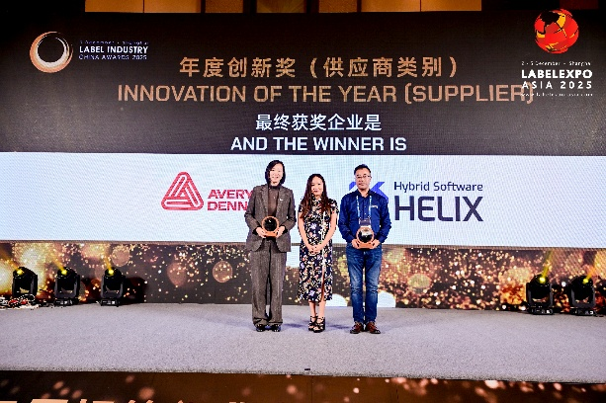
Caption: Bob Zhang, OEM Sales Manager, Asia Pacific, receives the Label Industry China Award for Innovation – Technology at the award ceremony at the Shanghai Pudong Kerry Centre Hotel.
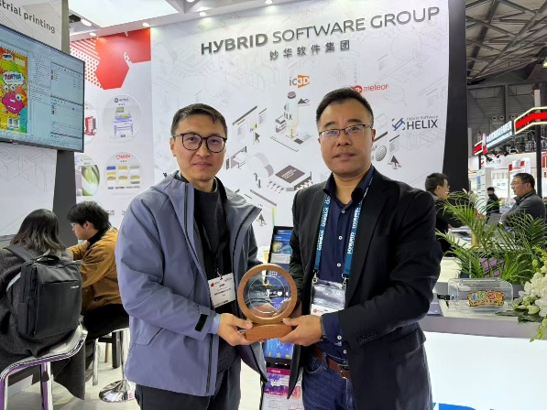
Caption: Sheldon Wang, Technical Sales Consultant, and Bob Zhang, OEM Sales Manager, Asia Pacific, from Hybrid Software Helix with the Label Industry China Award 2025.
About Hybrid Software Helix

Hybrid Software Helix, formerly known as Global Graphics Software, is a leading developer of smart software components for print OEMs and ISVs. Technologies include SmartDFE™, Harlequin Core™, ScreenPro Core™, Mako Core™ and the ColorLogic Core SDK. Customers include HP, Canon, Durst, Roland, Kodak and Agfa. The roots of the company go back to 1986 and to the iconic university town of Cambridge, and today the majority of the R&D team is still based near here. Helix owns 100% of its Intellectual Property and is independent of any printer manufacturer. It is the OEM Software business unit of Hybrid Software Group PLC (Euronext: HYSG). For more information visit hybridhelix.com
Media Contacts
In China
Bob Zhang
OEM Sales Manager – Asia Pacific
Email: bob.zhang@hybridsoftware.com
Tel: +86 (0)13601858427
In the United Kingdom
Paula Halpin
PR & Marketing Manager
Email: paula.halpin@hybridsoftware.com
Tel: +44 (0)1223 926017

