
PRESS RELEASE

Sabert leads the way with high-performing no intentionally added PFAS pulp packaging

Sabert Corporation Europe is proud to launch its new fully home compostable and recyclable foodservice packaging range. Made from renewable plant-based resources, the range is free from intentionally added PFAS and fully compliant.

Reflecting Sabert’s ongoing commitment to innovation, the new ranges have been developed and validated over time to deliver the performance customers expect.

“We chose to take our time rather than rush to market,” explains Alex Noake, Senior Vice President and Managing Director for Sabert Europe. “Most ‘PFAS free’ solutions we’ve tested simply haven’t performed and we have been inundated with requests from customers who continue to see Sabert as credible pulp innovators. We confidently offer pulp packaging that’s food safe, home compostable, recyclable and reliable in demanding foodservice and retail environments.”

“In the foodservice market, pulp packaging with no added PFAS options have faced performance challenges, a gap Sabert’s new ranges are designed to close,” Noake adds: “Just recently I was served an Asian-fusion meal in a pulp tray lined with greaseproof paper, a clear sign the bagasse tray itself wasn’t up to the job. The result was predictable. the paper became soggy, tore apart, and mixed with the food, undermining both the dining experience and the environmental intent. Worse still, many of those greaseproof liners still contain PFAS, completely defeating the purpose of using a ‘PFAS free’ base in the first place. Our goal was to avoid those compromises entirely by developing solutions that perform flawlessly without needing additional packaging or shortcuts.”

To align with new regulatory requirements, Sabert has evolved its entire pulp portfolio into the HC (home compostable) range. Building on this foundation, Sabert introduced Pulp Ultra, a next-generation, no-intentionally-added-PFAS formulation that meets both legislative standards and customers’ expectations for superior strength and heat resistance. This will be available early next year. Together, these ranges give customers a choice between a standard home-compostable option and an ‘Ultra’ high performance solution, both of which meet Sabert’s rigorous quality standards.

Be ready for upcoming European regulation

“At Sabert, we take food safety to heart,” says Sabert Quality Environment, Health & Safety Manager Isabelle Ernotte. “Every product we make is rigorously tested to comply with food safety standards. Our commitment is to help customers transition responsibly and confidently as new legislation comes into effect.”

Sabert’s existing pulp ranges containing PFAS substances remain fully compliant and safe for use, meeting all current UK, European and national food-contact regulations. From 12 August 2026, Regulation (EU) No 40/2025 on packaging and packaging waste (PPWR) introduces new measures, including Article 5(5) paragraph 5, of Regulation (EU) No 40/2025 which restricts and introduces limits on the presence of per- and polyfluoroalkyl substances (PFAS), often referred to as ‘forever chemicals’ due to their persistence in the environment and the human body. Sabert’s new solutions help customers to stay ahead of these changes with products that already meet the next generation of sustainability standards.

“Sabert has over 40 years’ experience in providing innovative, value-added products to the highest quality standards, supported by outstanding customer service,” concludes Noake. ”Our mission is to offer our clients the best guarantees in terms of quality, safety and service, so talk to us to ensure you are choosing the most appropriate foodservice packaging or if you would like to better understand the potential impact of upcoming legislation.”

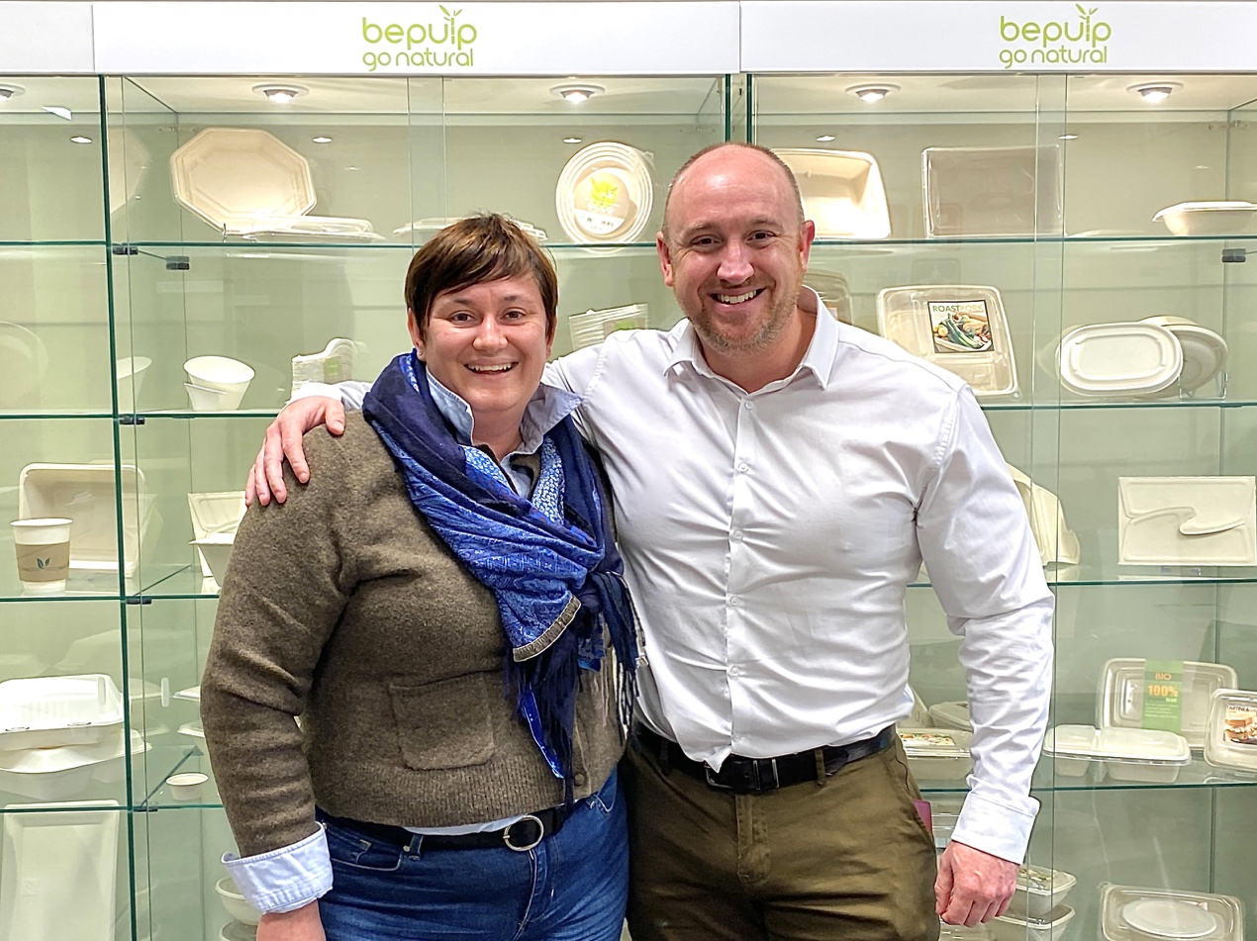

Sabert Quality Environment, Health & Safety Manager Isabelle Ernotte with Alex Noake, Senior Vice President and Managing Director for Sabert Europe.
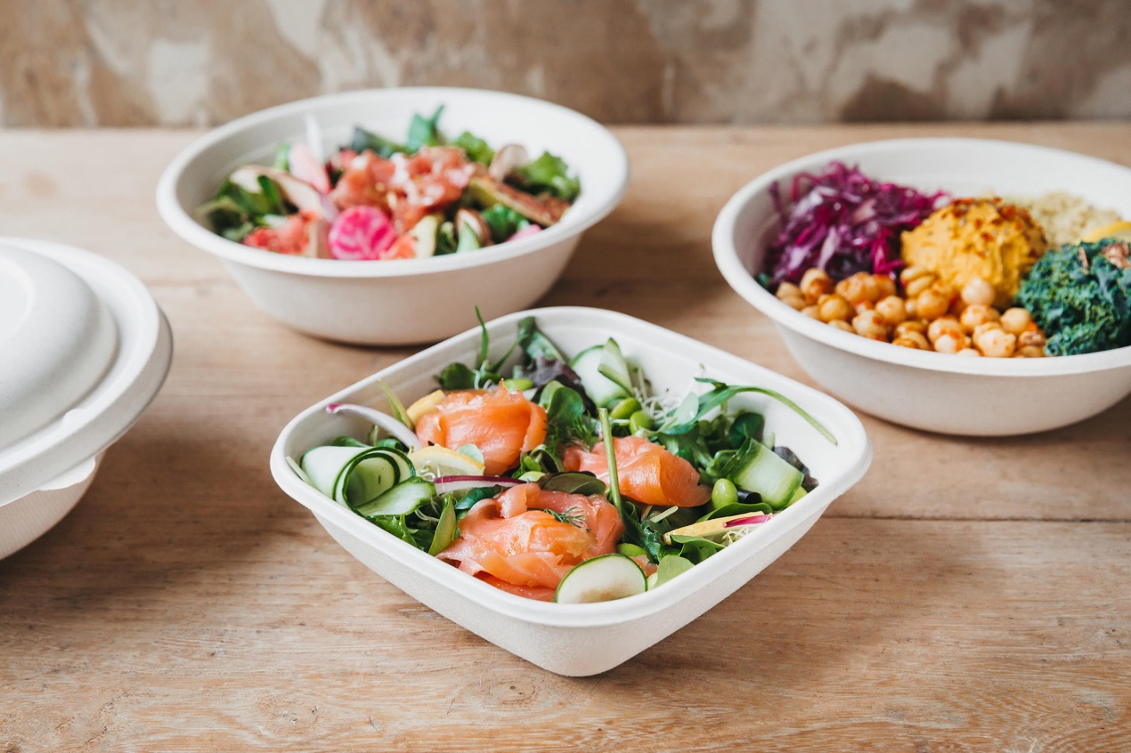

Sabert’s new HC range is home compostable and recyclable, and is made from renewable plant-based resources with no intentionally added PFAS.

__

For further information, please contact:
Bill Bruce,
Suzanne Howe Communications
Tel: +44 (0)2034 680923
Email: bill@suzannehowe.com
Web: www.suzannehowe.com

Or visit: www.sabert.eu

About Sabert

Sabert is specialised in manufacturing and marketing food packaging, disposable high-quality tableware and compostable food packaging and tableware. Through various partnerships established with some of its customers, Sabert Corporation Europe commits to develop its products and its production’s processes in a sustainable way. With 40 years of experience, Sabert provides innovative, value-added products to the highest quality standards supported by outstanding customer service. We have given ourselves the mission to offer our clients the best guarantees in terms of quality, safety and service. Today, our product solutions fulfil this vision and have earned the trust and loyalty of customers around the globe. As our employees and clients agree, Sabert makes food look great!

In July 2025, Sabert acquired Colpac Limited, a leading UK-based manufacturer of sustainable paperboard packaging solutions for the food-to-go foodservice and industrial markets.

