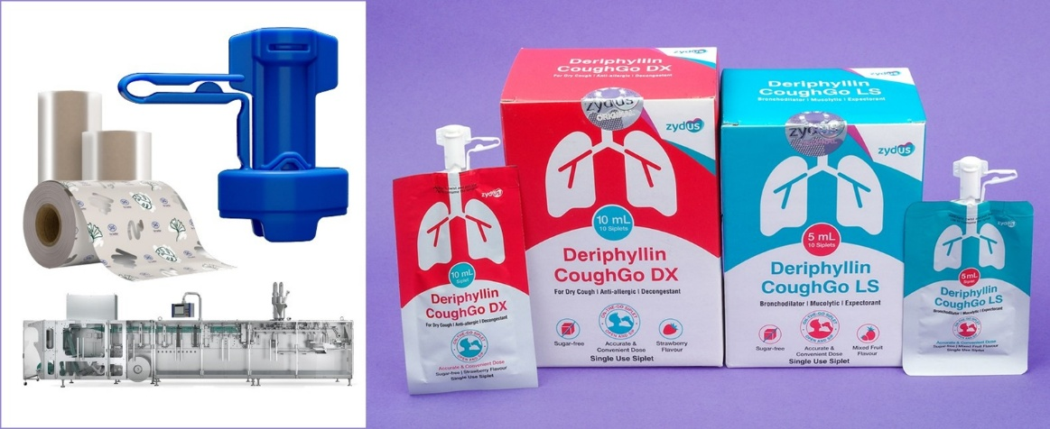
Featuring SIG StrawCap 30 Linked and SIG Motion Servo 3.2 filling technology
Zydus and SIG sign deal for novel packaging solution to launch India’s first single-serve spouted pouches for liquid cough and cold medication

National, 18 November 2025 - Zydus Lifesciences Ltd., a global innovation-driven lifesciences company, and SIG, a leading packaging solutions provider, entered into an agreement to pioneer packaging of liquid cough and cold medication in single-serve spouted pouches featuring the tethered spout solution SIG StrawCap 30 Linked and the SIG Motion Servo 3.2 filling technology. This launch marks a significant advancement in pharmaceutical packaging, delivering precisely dosed medicine, improved hygiene, and reduced product waste.

Abdelghany Eladib, President & General Manager, India, Middle East and Africa at SIG: “We are proud to be taking this step together with Zydus, bringing to market an innovation with substantial potential in the pharmaceutical sector. Single-serve spouted pouches for pre-portioned pharmaceutials, such as cough syrup, position us as frontrunners in the industry and represent a significant advancement in both patient comfort and safety.”

The new packaging solution for Zydus’ “Deriphyllin CoughGo” enables 5 ml and 10 ml mini-portions of ready-to-consume medicine in spouted pouches, also known as siplets. Traditionally, cough medications are offered in multi-serve bottles, where precise dosing is often difficult or leads to product waste when unused medicine expires before the packaging is emptied. Zydus' move to single-serve spouted pouches directly addresses these issues by offering convenient, portable, and unbreakable alternative, where a precise dosage is delivered in the pouch. The new packaging solution reduces contamination risk and improves ease and convenience for patients. No spoons, syringes, or other tools are required, making this solution ideal for use on the go.

At the core of this innovation is SIG StrawCap 30 Linked, a tethered spout solution with a straw included. It enables direct, mess-free consumption without the need for additional straws or dosing devices. The solution combines all convenience features of a conventional spouted pouch closure combined with the benefit of a very lightweight and resource-efficient design. It uses 3x less plastic compared to a conventional pouch closure with cap. This makes SIG StrawCap 30 Linked a cost-effective, resource-saving, and equally environmentally conscious solution, as the cap remains attached to the pack, increasing the chance of avoiding plastic litter. The solution is set to be combined with SIG Terra RecShield film in the future, fully designed for recycling.

The spouted pouches are formed and filled using SIG’s Motion Servo 3.2 horizontal form-fill-seal (HFFS) machine, with patented servo technology for high-precision filling. “With SIG Motion Servo 3.2 installed at Zydus and SIG StrawCap 30 Linked, we are transforming how liquid medications are delivered – making them easier to dose, safer to consume, and less likely to go to waste,” said Christoph Wegener, Chief Markets Officer at SIG. “Our partnership with Zydus shows how the right technology can solve real challenges in healthcare delivery.”

For Zydus, the adoption of single-serve spouted pouch solutions for pharmaceutical products reflects its commitment to bringing meaningful innovation to the Indian healthcare market. The spouted pouches enhance dosing accuracy, reduce contamination risk, and significantly improve convenience for patients.

“Our goal at Zydus is to make effective medication more accessible and consumer-friendly,” said Dr. Sharvil P. Patel, Managing Director, Zydus Lifesciences Limited. “Continuing with our patient-centric approaches, we are introducing Deriphyllin CoughGo in single-serve spouted pouches utilizing SIG’s advanced filling technology. We have always championed innovation that brings greater convenience for our patients and with this launch we set a new standard for safe intake of medicine which also helps in reducing product waste in India.”

Dhandutt Shah, Managing Director India for SIG’s bag-in-box and spouted pouch business: “We are excited to collaborate with Zydus to introduce single-serve spouted pouches to India’s pharmaceutical sector, combining SIG’s advanced spouted pouch technology with a shared commitment to quality, safety, and patient wellbeing. This innovation not only benefits manufacturers, it improves the everyday lives of consumers.”

The information contained in the press release hereinabove is intended to be general, educational information in relation to developments and innovation in the packaging space and is not to be construed as advertisement or promotion of drugs or related pharmaceutical products.

About Zydus Lifesciences
Zydus Lifesciences Ltd. with an overarching purpose of empowering people with freedom to live healthier and more fulfilled lives, is an innovative, global lifesciences company that discovers, develops, manufactures, and markets a broad range of healthcare therapies. The group employs over 27,000 people worldwide, including 1,400 scientists engaged in R&D, and is driven by its mission to unlock new possibilities in lifesciences through quality healthcare solutions that impact lives. The group aspires to transform lives through path-breaking discoveries. For more details visit www.zyduslife.com

About SIG
SIG is a leading solutions provider of packaging for better – better for our customers, for consumers, and for the world. With our unique portfolio of aseptic carton, bag-in-box, and spouted pouch, we work in partnership with our customers to bring food and beverage products to consumers around the world in a safe, sustainable, and affordable way. Our technology and outstanding innovation capabilities enable us to provide our customers with end-to-end solutions for differentiated products, smarter factories, and connected packs, all to address the ever-changing needs of consumers. Sustainability is integral to our business, and we strive to create a regenerative food packaging system.

Founded in 1853, SIG is headquartered in Neuhausen, Switzerland, and listed at the SIX Swiss Exchange. The skills and experience of our approximately 9,600 employees worldwide enable us to respond quickly and effectively to the needs of our customers in over 100 countries. In 2024, SIG produced 57 billion packs and generated €3.3 billion in revenue. SIG also has an AAA ESG rating by MSCI, a Platinum CSR rating by EcoVadis, and is included in the FTSE4Good Index. For more information, visit www.sig.biz

Picture Caption:
Zydus Lifesciences Ltd., a global innovation-driven lifesciences company, and SIG, a leading packaging solutions provider, have entered into an agreement to pioneer packaging of liquid cough and cold medication in single-serve spouted pouches featuring the tethered spout solution SIG StrawCap 30 Linked and the SIG Motion Servo 3.2 filling technology. This launch marks a significant advancement in pharmaceutical packaging, delivering precisely dosed medicine, improved hygiene, and reduced product waste.
Photo: SIG

Your contact for media inquiries:
Heike Thevis - Press Officer at SIG
Tel: +49 (0)2462 79 2608
Email: heike.thevis@sig.biz

For Press related queries, reach out to
Pratham.ahuja@kaizzencomm.com
9205765720

*********************************************************

