**Press release**

October 13, 2025

**FOBA presents NextGen Y-Series at productronica 2025**

**Selmsdorf, Germany – FOBA Laser Marking + Engraving, a leading provider of laser marking solutions, will present the latest generation of the Y series at productronica 2025 in Munich from November 18 to 21. The Y.0202 and Y.0602 fiber lasers set new standards in precision, flexibility, and efficiency for industrial product marking.**

[The fiber laser markers in the new Y-Series](https://www.fobalaser.com/products/laser-marking-system/fiber-laser-marker-pulsed-cw/y0x02-series/) have been specially developed for demanding applications in metal and plastics processing, such as in the automotive, medical, and electronics industries. With a market-leading focus range of up to 99 mm, they enable marking at different height levels without repositioning the components. This reduces setup times and increases productivity.

Thanks to adjustable pulse widths and outputs of 20 W or 60 W, the lasers are optimized for high-speed applications. Precise control of the marking parameters ensures high-contrast, material-friendly markings with minimal heat input. An optional integrated vision system and a full-field camera enable precise alignment, automatic adjustment, and real-time validation of the marking content. Intelligent marking field compensation ensures consistently high quality, regardless of the shape and position of the workpiece.

In addition, FOBA will be showcasing the [V.0042-uv](https://www.fobalaser.com/products/laser-marking-system/uv-laser-marker/) at the trade fair, a [UV laser](https://www.fobalaser.com/products/laser-marking-system/uv-laser-marker/) that excels at producing high-contrast markings on sensitive products.

The compact laser head is compatible with all M-series machines and can be easily integrated into existing production lines. The laser will be presented in the compact M1000 laser workstation..

FOBA has been developing solutions for industrial product marking for many years. The focus is on practical technology and individual consulting—with the aim of supporting companies worldwide in implementing efficient and reliable marking processes.

Visitors to productronica are cordially invited to visit the FOBA booth to learn about the latest developments and discuss their individual requirements. Appointments for consultations can be made in advance at info@fobalaser.com. Interested parties can also obtain a free trade fair ticket there. Further information about the trade fair is available at: <https://productronica.com/de/>.

**FOBA Laser Marking + Engraving**

[**https://www.fobalaser.com/**](https://www.fobalaser.com/)

**Images for editorial use**

**Images can be downloaded free of charge for editorial use at:**

<https://www.fobalaser.com/newsroom-events/news-presse/productronica/>

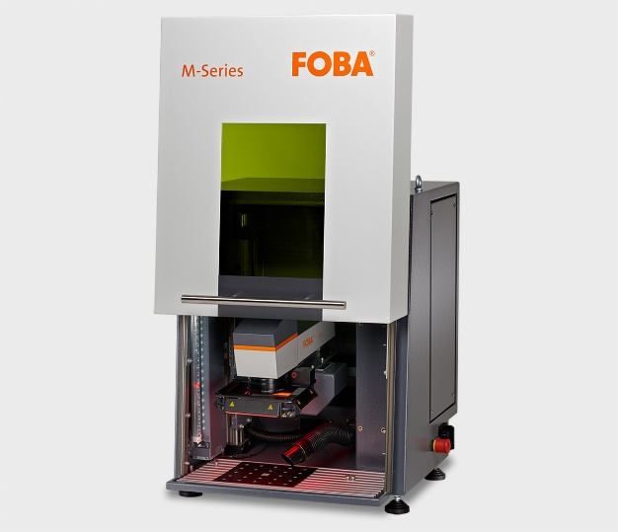

FOBA M1000 laser marking workstation, into which a FOBA UV laser marker can be integrated. (Image rights: FOBA)

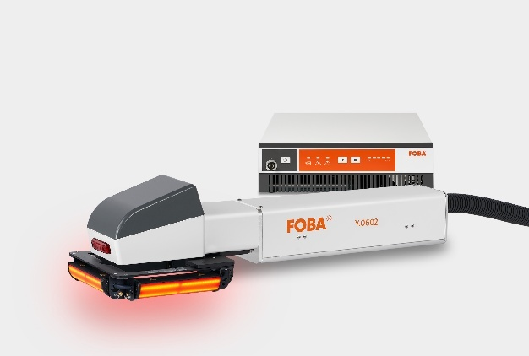

New Y-Series specially designed for Multi-Level Marking and a wide variety of materials. (Image rights: FOBA)

Weitere Informationen sowie Text- und Bild­material erhalten Sie von:

For additional information and images for editorial use please contact:

**Kathrin Urban |** Campaign & Event Manager

**ALLTEC Angewandte Laserlicht Technologie GmbH** | FOBA Laser Marking + Engraving  
An der Trave 27 – 31 | 23923 Selmsdorf

Tel.: +49 (0)38823 55-440

[kathrin.urban@fobalaser.com](mailto:kathrin.urban@fobalaser.com) | [www.fobalaser.com](http://www.fobalaser.com)

**Über FOBA** [**www.fobalaser.com/de/**](http://www.fobalaser.com/de/)

FOBA Laser Marking + Engraving (Marke der ALLTEC Angewandte Laserlicht Technologie GmbH) ist einer der führenden Hersteller und Anbieter von innovativen Lasermarkierlösungen. FOBAs Beschriftungslaser, Lasermarkierma­schinen und bildgebende Kennzeichnungsworkflows kommen vor allem in der Automobilzulieferindustrie, Medizintechnik, Elektronik und **Kunststoffindustrie sowie im** Werkzeug-, Metall- und Formenbau **zur Kennzeichnung** einer Vielzahl an Materialien und Produkten zum Einsatz. Ein weltweiter Vertrieb sowie internationale Vertriebspartner und Servicestandorte bedienen die globalen Märkte. Seit 2004 gehört ALLTEC/FOBA mit der Firmenzentrale in Selmsdorf bei Lübeck zur US-amerikanischen Veralto Corporation.

**About FOBA** [**www.fobalaser.com**](http://www.fobalaser.com)

FOBA Laser Marking + Engraving (brand of ALLTEC Angewandte Laserlicht Technologie GmbH) is one of the leading suppliers of advanced laser marking systems. FOBA develops and manufactures marking lasers for integration as well as laser marking workstations with vision assisted marking workflows. FOBA technology is being applied for the direct part marking of any kind of metals, plastics, or other materials in industries like automotive, medical, electronics, plastics or tool, metal and mold making. With its worldwide sales and service branches and its headquarters near Lübeck/Hamburg (Germany) ALLTEC/FOBA is part of the Veralto Corporation.