PRESS RELEASE

**Mondi supports Özler Tarım reduce food waste in long distance shipments**

* *Mondi's recyclable packaging solution ensures maximum product protection during long sea freight journeys.*
* *Özler Tarım achieved a 15% increase in production capacity at its Adana facility thanks to new packaging solution.*
* *Compact packaging design enhances operational efficiency.*

**2 October 2025** – Mondi, a global leader in sustainable packaging and paper, has partnered with Özler Tarım, one of Türkiye’s leading fresh fruit and vegetable exporters, to co-create a customised sustainable packaging solution that protects products and optimises operational processes.

Operating since 1982, Özler Tarım exports high-quality, fresh produce to Japan, Canada, the United States, Europe, Ireland, United Kingdom and East Asia countries. The company aimed to reduce food waste by improving its packaging to suit the humidity, temperature fluctuations and long-distance shipment requirements.

Mondi’s product innovation experts worked with Özler Tarım’s team to develop a durable, sustainable and efficient packaging solution. The new packaging features a double-wall corrugated fibre structure and a flat-stackable design, streamlining both production and shipping processes. Özler Tarım has since achieved a 15% increase in production capacity at its Adana facility and costs from packaging defects – such as compensation for damaged goods – have been eliminated.

Mehtap İncesöz, Planning & Supply Chain Manager at Özler Tarım, says: “Mondi’s 100% recyclable corrugated solution aligns perfectly with our environmentally conscious export model. The enhanced strength of the new packaging prevents waste from collapse and product loss, ensures product quality, and enhances customer satisfaction. Its robust structure withstands the humidity, stacking pressure, and movement that typically occur during long sea journeys, ensuring our products arrive undamaged. The positive feedback we’ve received from our markets about this packaging – reflecting the quality of our brand – has been truly rewarding.”

Metin Morhayim, Sales and Marketing Director at Mondi Corrugated Turkey, adds: “We deliver tailor-made solutions for each customer’s unique business needs. Our work goes beyond packaging – we aim to create holistic value by improving process efficiency and advancing sustainability goals. This project with Özler Tarım stands as a successful example of our long-standing partnership.”

Explore Mondi´s range of corrugated packaging for fresh fruit and vegetables: [www.mondigroup.com/products-and-solutions/corrugated-solutions/fresh-fruit-and-vegetable-packaging](https://www.mondigroup.com/products-and-solutions/corrugated-solutions/fresh-fruit-and-vegetable-packaging).

/ends

**About Mondi**

Mondi is a global leader in packaging and paper, contributing to a better world by producing products that are sustainable by design. We employ 24,000 people in more than 30 countries and operate an integrated business with expertise spanning the entire value chain, enabling us to offer our customers a broad range of innovative solutions for consumer and industrial end-use applications. Sustainability is at the centre of our strategy, with our ambitious commitments to 2030 focused on circular driven solutions, created by empowered people, taking action on climate.

In 2024, Mondi had revenues of €7.4 billion and underlying EBITDA of €1.0 billion. Mondi is listed on the London Stock Exchange in the ESCC category (MNDI), where the Group is a FTSE100 constituent. It also has a secondary listing on the JSE Limited (MNP).

[www.mondigroup.com](http://www.mondigroup.com)

**Contact:**

Anika Köstinger

Senior Content Manager, Corrugated Packaging

Tel: +43 664 4162546

Email: [anika.koestinger@mondigroup.com](mailto:anika.koestinger@mondigroup.com)

Çiğdem Arkant

Corporate Communications Manager, Mondi Corrugated Turkey

Tel: +90 530 152 45 50

Email: [cigdem.arkant@mondigroup.com](mailto:cigdem.arkant@mondigroup.com)

Kim Lommaert

EMG

Tel: +31 164 317 021

Email: [klommaert@emg-marcom.com](mailto:klommaert@emg-marcom.com)

**Photos:**

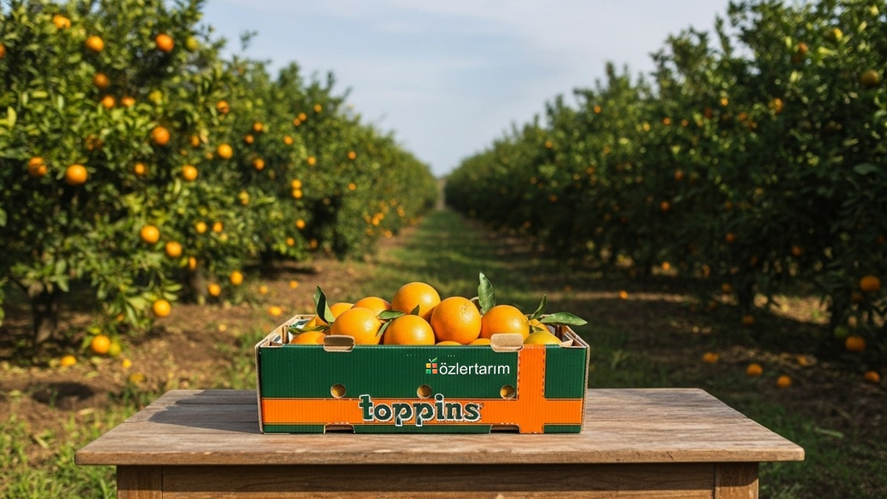

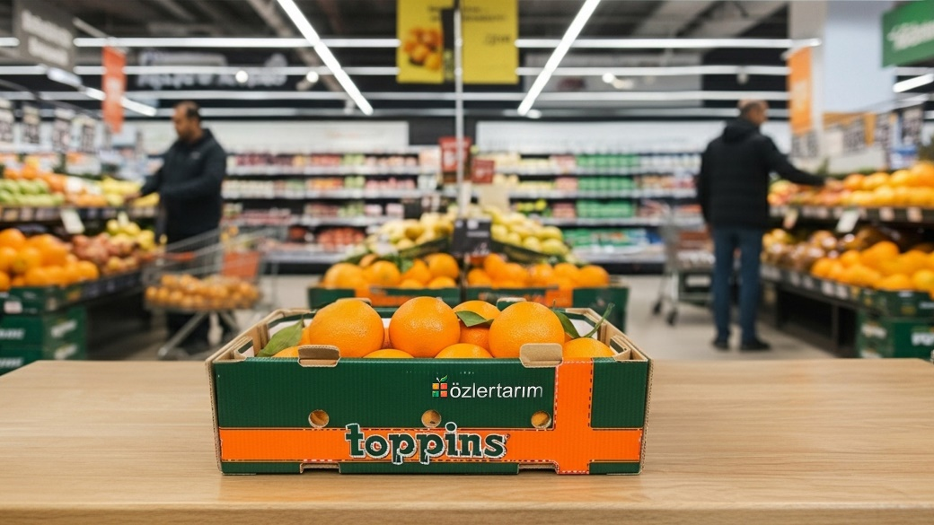

Mondi supports Özler Tarım reduce food waste in long distance shipments.   
(Photos: Mondi, PR345)

This press release and relevant photography can be downloaded from

[www.PressReleaseFinder.com](http://www.PressReleaseFinder.com).

Alternatively for very high resolution pictures please contact Kim Lommaert ([klommaert@emg-marcom.com](mailto:klommaert@emg-marcom.com), +31 164 317 021).