Editorial Contact: Ana Juraga [ana.juraga@ecocortec.hr](mailto:ana.juraga@ecocortec.hr)

Cortec® Europe Advertising Agency + 385 (0) 1 4854 486

Company Contact: Ivana Radic Borsic iborsic@cortecvci.com

Cortec® Corporation: + 385(0) 31 705 011

**Attention: Editor**

**October 15, 2025**

**PRESS RELEASE**



**Ivana Radic Borsic Named New Executive Vice President (EVP) and Managing Director of CorteCros:**

Cortec® Appoints New EVP to Command Global Growth and Sustainability Drive from CorteCros EU Manufacturing Hub

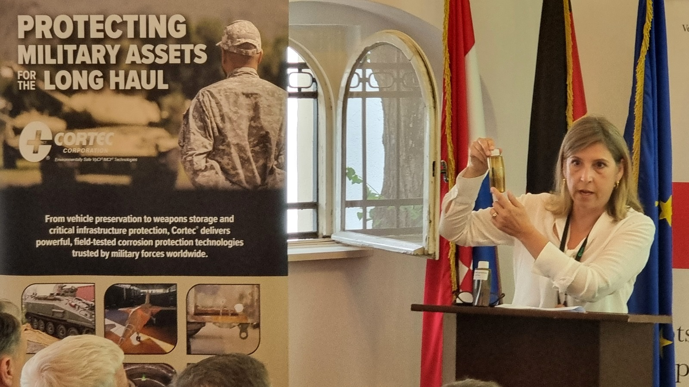Cortec® Corporation, a global leader in environmentally safe corrosion protection technologies, is proud to announce the appointment of Ivana Radic Borsic to the position of Executive Vice President (EVP) and Managing Director of its key European subsidiary, CorteCros d.o.o. Her new role gives her full command of the company's strategic growth, sales, logistics, and production throughout Europe and globally.

**Ivana Radic holding a presentation on behalf of Cortec® Corporation earlier this year at the Berlin Military Forum.**

Ms. Radic is a proven and highly respected executive who also retains her current title as Vice President of Sales, Europe, for Cortec® Corporation. Her dual leadership ensures tight integration between CorteCros’s operational capabilities and Cortec’s broader European sales strategy. With this new focus, she will also be leading the team of growing professionals at the Croatian facilities, emphasizing skill development alongside expansion.

**The Strategic Importance of the CorteCros Hub**

In her expanded role, Ms. Radic will focus on maximizing the output of the company's crucial Croatian facilities to meet growing international demand. CorteCros's manufacturing facility and laboratory are strategically located in the harbor near Split, making it the main logistics and manufacturing hub for key European markets. This hub is a critical point for supplying Cortec® products efficiently across the EU, the Middle East, and Southeast Asia. She will provide operational oversight for all major functions, with the core goal of streamlining everything to boost efficiency across the board. Her key responsibilities include:

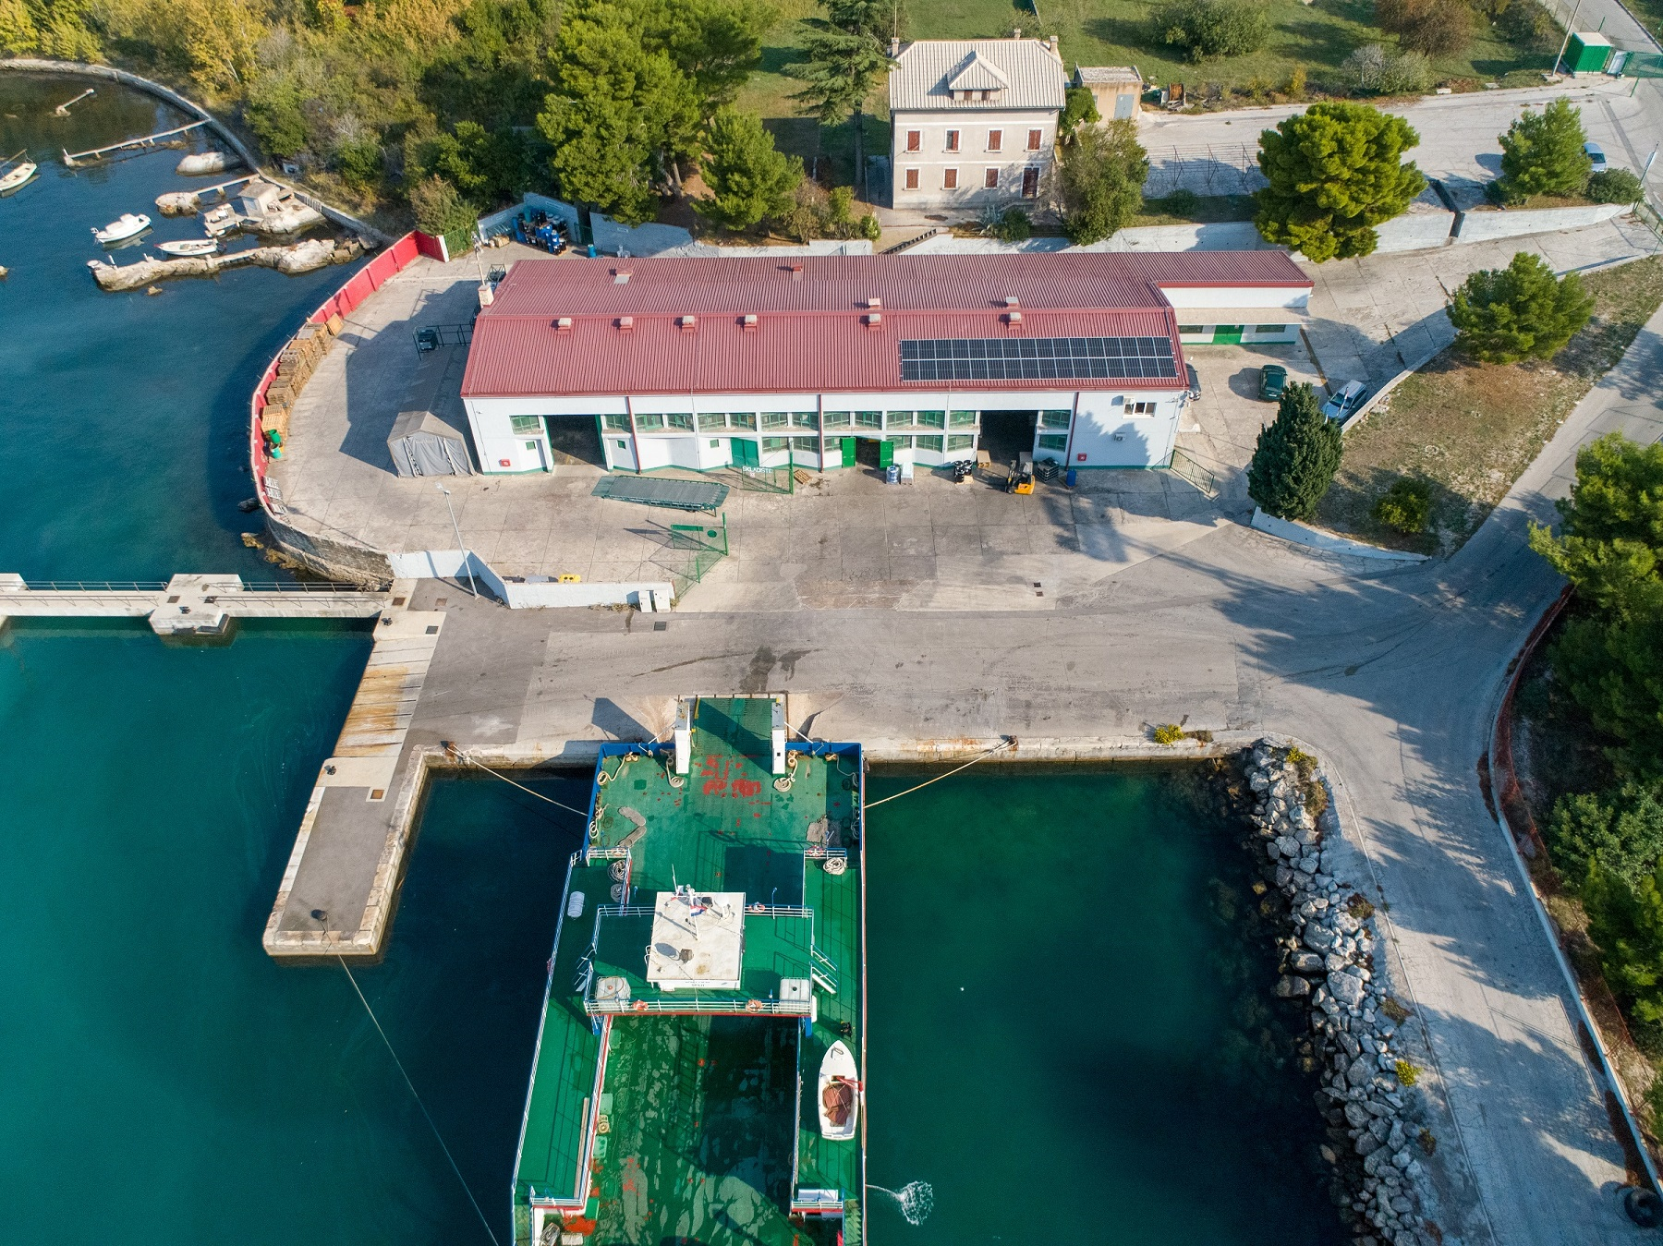

**Manufacturing and Global Distribution**: Directing the complex operations of the 1,114.84 m2 seaside production and production facility in Split, with the goal of supporting Cortec’s EU distribution network. She will be overseeing the production of VpCI®/MCI® products, a vital operation initiated in 2019 to ensure product availability for the EU market. This also includes managing the in-house QC laboratory and driving new product development.

**Pioneering Sustainability:** Leading Cortec's environmental commitment with an emphasis on green technologies.

**Market Development**: Through her VP of Sales role, she will continue to set the direction for Europe-wide sales growth, technical support, and the acquisition of new key accounts, ensuring that the operational efficiency of CorteCros directly supports ambitious commercial targets.

"Ivana has been an incredibly valuable part of the Cortec family for 26 years. She's been instrumental in growing our presence across Europe and beyond. Her expertise as VP Sales has given her unparalleled insight into our customers' needs, and her oversight of our strategic facilities in Europe including the solar-powered hub in Split makes her the ideal leader for CorteCros," said Boris Miksic, CEO of Cortec® Corporation. "She embodies the strategic, sustainable, and results-driven vision we have for our entire European operations."

Ms. Radic commented on her appointment: “I’m honored to take on this expanded role at such a vital time for CorteCros. From our Croatian facilities we can supply advanced, REACH-compliant, and sustainable corrosion solutions across three major continents. My focus will be on using our production and logistics to grow sales and develop new products while honoring Cortec’s core values of sustainability and the circular economy. Our goal is to deliver maximum value to every customer and distributor.”

**About CorteCros®**

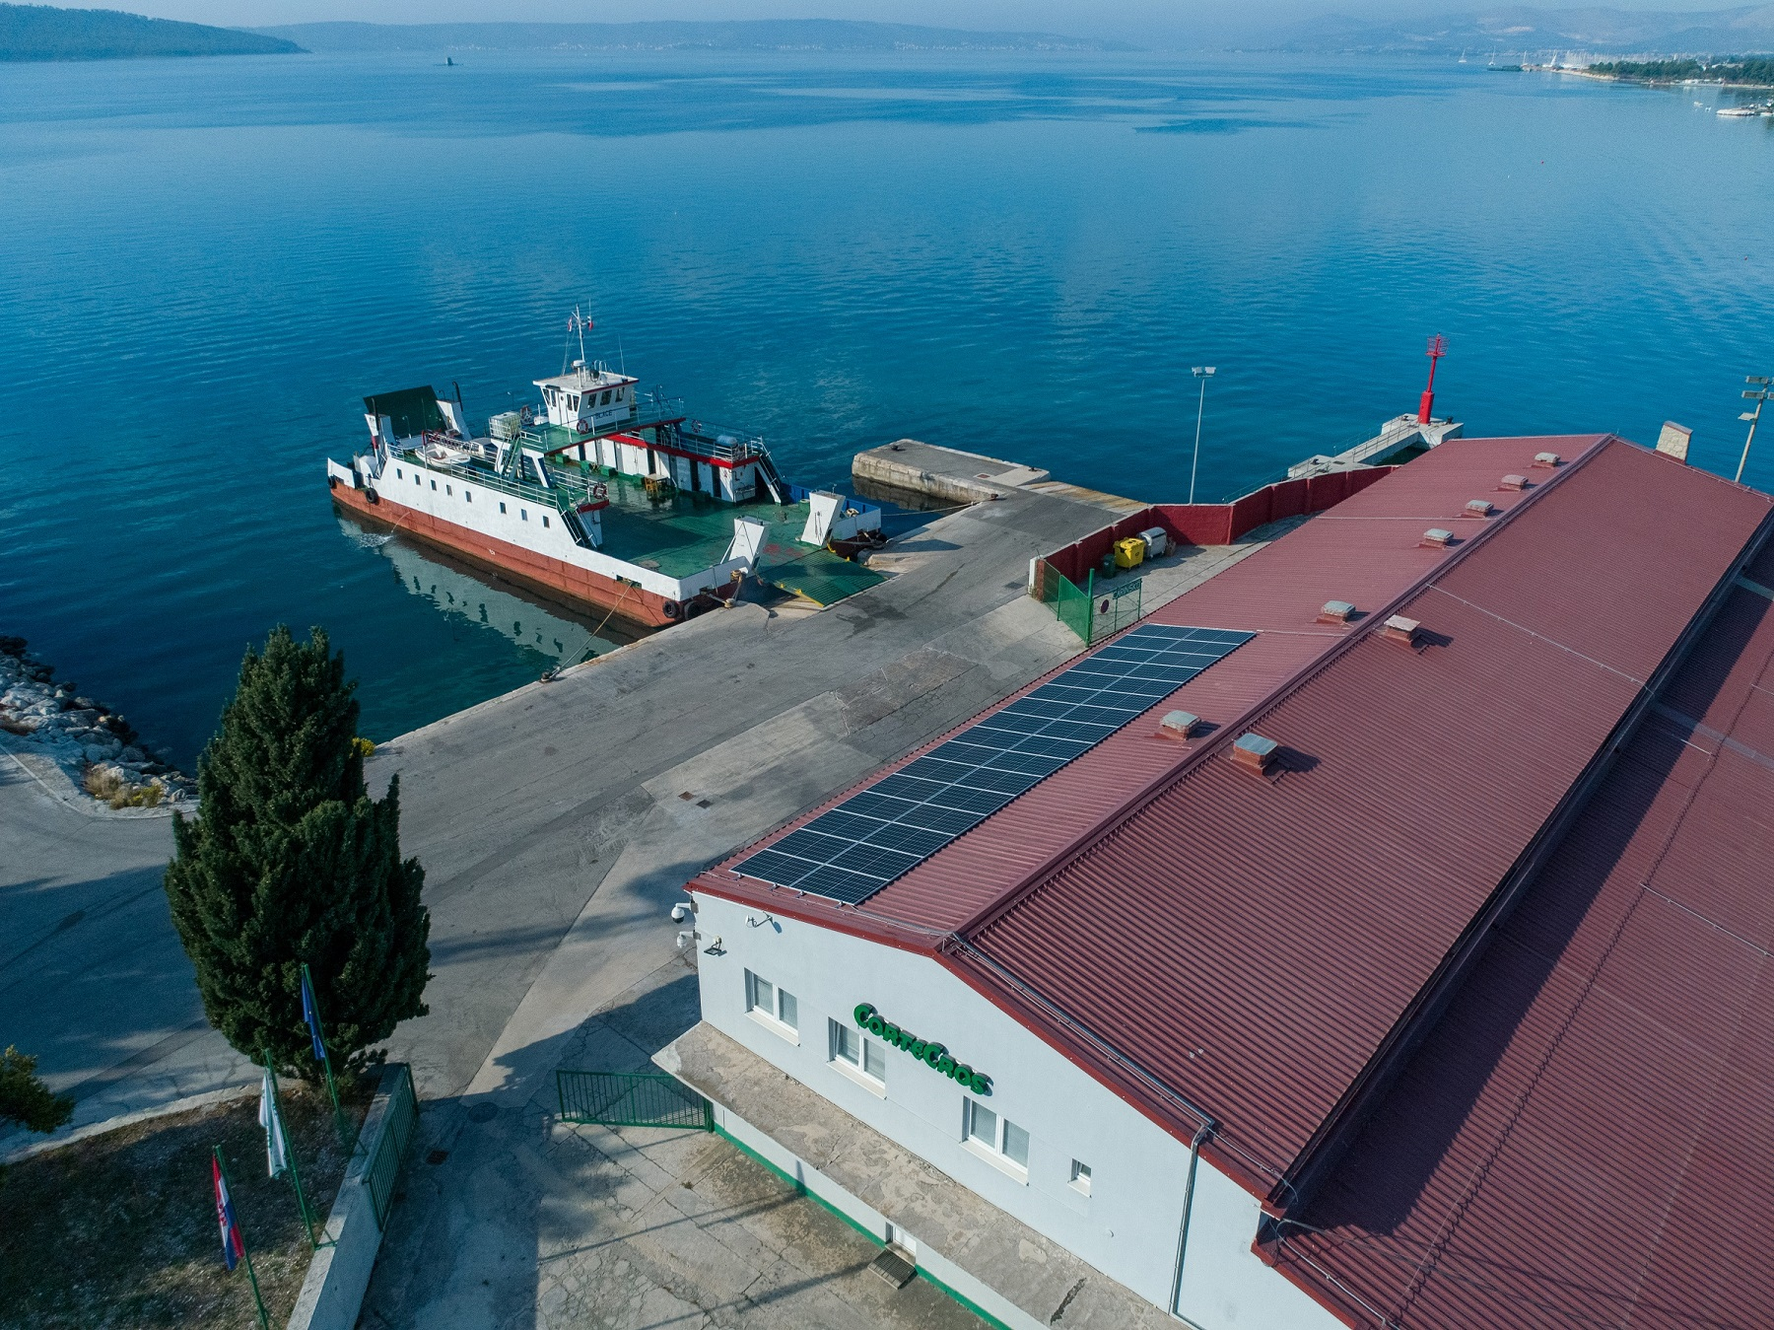CorteCros® is a subsidiary of Cortec® Corporation that provides comprehensive technical, logistical, and distribution support for Cortec® products throughout Europe, the Middle East, and Southeast Asia. Headquartered with new administrative offices in Zagreb, Croatia, and operating its main production and logistics center in Split, CorteCros serves as a central hub for European distribution of world-class, environmentally safe corrosion protection and specialty products. The company is committed to investing in its growing team of professionals to ensure continued excellence. Following the installation of renewable energy infrastructure in 2022, the Split plant became 100% solar-powered, positioning the Croatian operation as a leader in green manufacturing within the specialty chemical industry.

**Need a High-Resolution Photo? Visit:** [**www.cortecadvertising.com**](http://www.cortecadvertising.com)

Cortec® Corporation is the global leader in innovative, environmentally responsible VpCI® and MCI® corrosion control technologies for Packaging, Metalworking, Construction, Electronics, Water Treatment, Oil & Gas, and other industries. Our relentless dedication to sustainability, quality, service, and support is unmatched in the industry. Headquartered in St. Paul, Minnesota, Cortec® manufactures over 400 products distributed worldwide. ISO 9001, ISO 14001:2004, & ISO 17025 Certified.