UFlex’s FlexiTubes to Showcase Next-Gen Sustainable and Aesthetic Tube Packaging Solutions at Beautyworld Middle East 2025
October 23, 2025, Noida, National Capital Region: FlexiTubes, the packaging tubes business of UFlex Limited, India’s largest multinational flexible packaging and solutions company, will be showcasing an advanced portfolio for the beauty and personal care industry at the 29th edition of Beautyworld Middle East, scheduled from October 27–29, 2025, at the Dubai World Trade Centre.
This year, FlexiTubes will present a product range that balances sustainability, functionality, and aesthetics. The portfolio includes Gloss Tubes, Metallika, Mattika, Matte Metallika, De-Metallized, and Optika, all designed to create a distinct shelf presence.
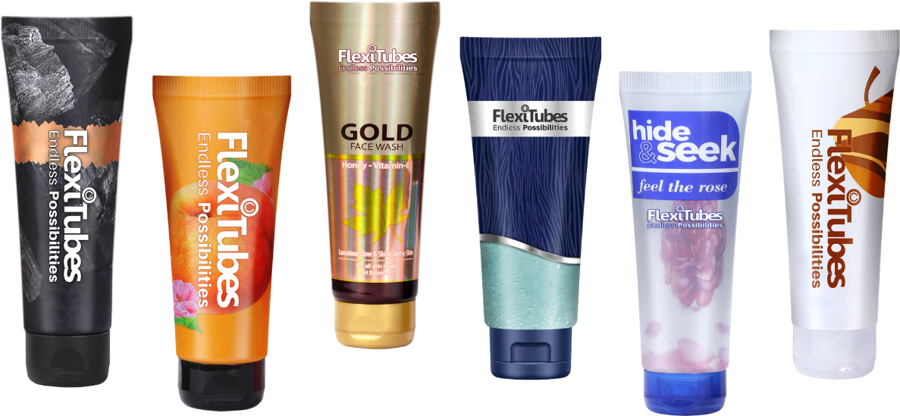
For brands seeking sustainable packaging solutions, FlexiTubes offers a diverse range — Kraftika (paper-based), Remika (recyclable), Greenika (PCR-based), and Earthika (biodegradable) tubes. The company will also showcase tubes in Plastic Barrier Laminate (PBL) and Aluminium Barrier Laminate (ABL) formats. In addition, FlexiTubes provides customised barrier solutions tailored to specific product requirements. These products are designed to reduce plastic dependency, improve recyclability, and support circular packaging. The range also features tubes made from recycled and paper-based materials, which support sustainability.
In addition to sustainable solutions, FlexiTubes will also showcase tubes with an invisible side seam and enhanced strength, offering a premium appearance and reliable performance. The tubes support 360° printing, enabling full-surface customization with high-definition graphics and a wide range of finishes. Alongside these innovations, it will also present advanced anti-counterfeit packaging solutions that combine overt and covert security features, including micro text, hidden text, UV ink printing, and holographic elements, to provide customized packaging that ensures product authenticity and protects against counterfeiting.

With its consistent focus on innovation and sustainable packaging design, UFlex’s FlexiTubes business continues to deliver value-added solutions that help global beauty and cosmetic brands differentiate themselves in a competitive marketplace.
Visit FlexiTubes at Hall 8, Booth B12 to explore advanced packaging solutions that reduce environmental impact, enhance product performance, boost brand appeal, and support the transition to a sustainable future.
For queries: corpcomm@uflexltd.com
About UFlex Limited:
UFlex is India’s largest multinational flexible packaging and solutions company. Since its inception in 1985, UFlex has grown from strength to strength and has built a strong presence across all verticals of the packaging value chain - packaging films, chemicals, aseptic packaging, flexible packaging, holography, engineering, and printing cylinders.
With a 12,000+ strong multicultural workforce across global regions that works toward developing innovative, value-added, and sustainable packaging solutions, the company has earned an irreproachable reputation for defining the contours of the ‘Packaging Industry’ in India and overseas. It provides end-to-end solutions to numerous Fortune 500 clients across various sectors such as FMCG, consumer product goods, pharmaceuticals, building materials, automobiles, and more, in more than 150 countries.
Headquartered in Noida, the National Capital Region, India, UFlex enjoys a global reach with advanced manufacturing facilities in India, UAE, Mexico, Egypt, USA, Poland, CIS, Nigeria, and Hungary.
A winner of various marquee global awards for product excellence, innovation, and sustainability, UFlex is the first company in the world to earn recognition at the Davos Recycle Forum in 1995 for conceptualizing the recycling of mixed plastic waste. For more details, please visit:www.uflexltd.com

