

**NEWS FOR IMMEDIATE RELEASE**

**Global Graphics Software unveils major new version of SmartDFE with advanced tools for labels and packaging**

**See SmartDFE at Labelexpo Europe 2025 on the Hybrid Software**

**stand, Hall 5, Stand 5E55**

**(Cambridge, UK, 10th September 2025)** Global Graphics Software, a leading developer of core digital printing technologies and the OEM business unit of Hybrid Software, today announced a major new release of SmartDFE™, the intelligent digital front end platform that drives high-speed label and packaging presses. This latest version introduces two powerful tools that will enhance efficiency for label press operators, improve connectivity with Management Information Systems (MIS) and Enterprise Resource Planning (ERP) platforms, and help print service providers streamline operations for faster turnaround and greater automation.

The new Label Studio feature in SmartDFE gives label press operators the ability to do late-stage planning and prepare jobs directly at the press. This functionality is particularly valuable when access to the prepress department is limited, enabling operators to react quickly to production demands and maintain workflow efficiency.

For customers seeking an advanced prepress solution, Hybrid Software’s optional PACKZ and STEPZ software are also available. These powerful market-proven PDF editors provide an all-in-one toolkit for prepress and variable data printing (VDP) creation, specifically developed for the labels and packaging sector.

Built on Hybrid Software’s trusted CLOUDFLOW workflow suite, MISLink enables seamless connection to MIS and ERP systems, ensuring smooth data exchange and operational transparency. It includes a foundation CLOUDFLOW installation that can easily scale as business needs evolve, giving print service providers the flexibility to grow without disruption.

Hybrid Software's highly experienced services team is available to assist in connecting SmartDFE with customers’ existing MIS and ERP systems. This collaborative approach ensures seamless connectivity and data exchange between workflows and backend systems, enhancing efficiency and streamlining operations.

"This new SmartDFE release represents a major step forward in driving efficiency and automation in label and packaging production," said Justin Bailey, Managing Director, Global Graphics Software. "The new Label Studio and MISLink features give print service providers increased flexibility and the connectivity they need to thrive in an increasingly competitive market. We hope that OEM printer manufacturers and integrators visiting Labelexpo will take the opportunity to see this latest release with its intuitive WYSIWYG user interface."

Last week, Global Graphics Software was formally presented with a King’s Award for Enterprise for SmartDFE. The accolade is the UK’s highest business honor and Global Graphics Software was one of only 46 companies in the UK to be recognized for outstanding innovation. For more information visit: www.globalgraphics.com/smartdfe

**ENDS**

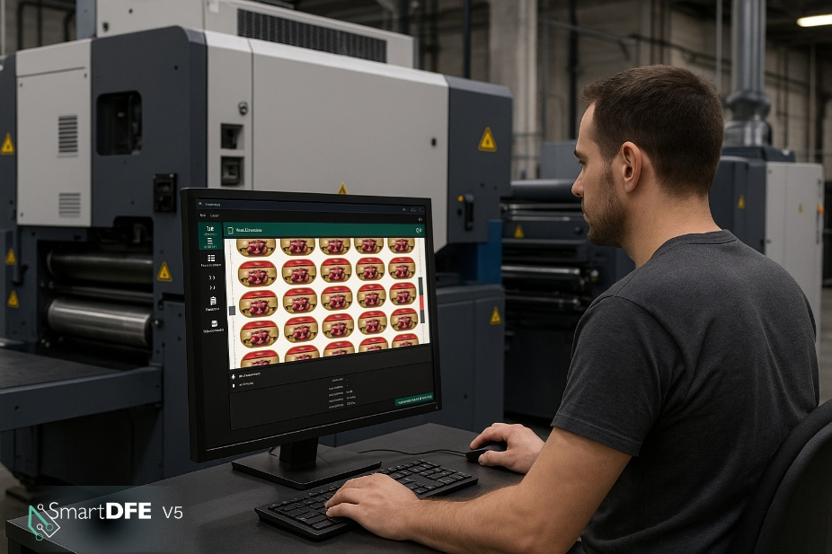

*Image:The latest version of SmartDFE*™, *the AI-accelerated digital front end platform for label & packaging presses, now includes features* *to give print service providers more flexibility and the connectivity they need to thrive in an increasingly competitive market.*

**About Global Graphics Software**

Global Graphics Software is a leading developer of smart software components for print OEMs and ISVs. Technologies include [SmartDFE](https://www.globalgraphics.com/products/smartdfe/labels-and-packaging)™, [Harlequin Core](https://www.globalgraphics.com/products/harlequin/)™, [ScreenPro Core](https://www.globalgraphics.com/products/screenpro)™, [PrintFlat](https://www.globalgraphics.com/technologies/printflat)™ and [Mako Core](https://www.globalgraphics.com/products/mako)™. Customers include [HP, Canon, Durst, Roland, Kodak and Agfa](http://www.globalgraphics.com/company/customers). [The roots of the company go back to 1986](https://www.globalgraphics.com/company/history/) and to the iconic university town of Cambridge, and today the majority of the R&D team is still based near here. Global Graphics Software owns 100% of its Intellectual Property and is independent of any printer manufacturer. Global Graphics Software is the OEM Software business unit of [Hybrid Software Group PLC](https://www.hybridsoftware.group/) (Euronext: HYSG). [www.globalgraphics.com](https://www.globalgraphics.com/)

**Media Contact**

**PR & Marketing Manager**

Paula Halpin   
Email: [Paula.halpin@globalgraphics.com](mailto:Paula.halpin@globalgraphics.com)

Tel: +44 (0)1223 926017