Press Note
UFlex Limited Recognised as a Top Employer 2025 in India

Delhi-NCR, August 07, 2025: UFlex Limited, India’s largest multinational flexible packaging and solutions company, has been recognised as a Top Employer in India by the Top Employers Institute, a leading global authority on HR excellence, certifying and guiding organizations to adopt world-class people practices.

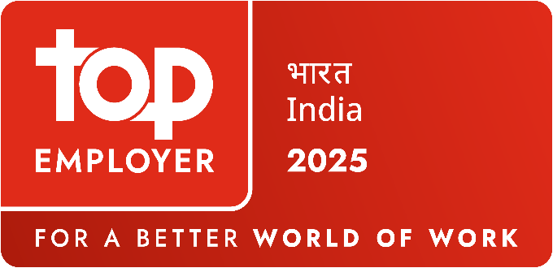
This global certification is a benchmark of excellence for people practices and stands as a testament to UFlex’s commitment to being an employer of choice by creating a workplace where both people and purpose thrive. Achieving this recognition involved a thorough assessment of its HR practices across key areas, including people strategy, talent acquisition, learning, diversity & inclusion, and well-being. The recognition reflects the strength of UFlex’s progressive people-first culture and highlights the progress it has made in making UFlex a preferred workplace.

Over the years, UFlex has built a strong people-centric ecosystem backed by employee-first policies and an open, agile culture. The organisation has introduced various initiatives aimed at supporting holistic development and employee well-being. The company offers curated learning paths, leadership development modules, and access to on-demand training through its internal learning platform, supporting continuous professional growth.

Sharing his thoughts on the achievement, Mr. Anantshree Chaturvedi, Vice Chairman and CEO, Flex Films International, said, “This recognition is an important milestone in UFlex’s journey. At UFlex, our people are at the centre of everything we strive to be as an organization. Being named a Top Employer India 2025 goes beyond just this recognition. It reflects the inclusive, progressive, and future-ready work culture we have strived to build. It motivates us to continue investing in our people, nurturing talent, and driving positive change in the packaging industry. This has always been our path to success.”
Commenting on the recognition, Mr. Chandan Chattaraj, President - Human Resources (India and Global), said, “At UFlex, HR transformation has been a continuous and all-encompassing journey focused on strengthening our people practices in alignment with evolving business goals. We nurture talent through future-focused learning, fostering agility and collaboration across our global ‘centers of excellence’, and promoting diversity and inclusion by ensuring equal growth opportunities. Over the years, we have received recognition from esteemed institutions, which has served as an important validation of our progress. Being certified by the Top Employers Institute is a proud moment that highlights our efforts in delivering best-in-class employee experience, making UFlex a preferred workplace.”

“Consistency in a not-so-consistent world? Amidst constant change—through technological advances, economic shifts, and evolving social landscapes—it is inspiring to see people and organisations rise to the challenge. This year, the Top Employers Certification Programme highlights the dedication of our Top Employers as they continue to set the standard, consistently delivering world-class HR strategies and practices. These Top Employers strive to foster growth and well-being, all while enriching the world of work. We are proud to celebrate
these people-first leaders and teams as the Top Employers for 2025!”, said, Mr. David Plink, Chief Executive Officer, Top Employers Institute.

The Top Employers Institute program certifies organisations that demonstrate excellence in delivering a superior employee experience. The programme has certified and recognised over 2,400 Top Employers in 125 countries/regions across five continents.

For queries: corpcomm@uflexltd.com

About UFlex Limited:
UFlex is India’s largest multinational flexible packaging and solutions company. Since its inception in 1985, UFlex has grown from strength to strength and has built a strong presence across all verticals of the packaging value chain - packaging films, chemicals, aseptic packaging, flexible packaging, holography, engineering, and printing cylinders.
With a 12,000+ strong multicultural workforce across global regions that works toward developing innovative, value-added, and sustainable packaging solutions, the company has earned an irreproachable reputation for defining the contours of the ‘Packaging Industry’ in India and overseas. It provides end-to-end solutions to numerous Fortune 500 clients across various sectors such as FMCG, consumer product goods, pharmaceuticals, building materials, automobiles, and more, in more than 150 countries. Headquartered in Noida, the National Capital Region, India, UFlex enjoys a global reach with advanced manufacturing facilities in India, UAE, Mexico, Egypt, USA, Poland, CIS, Nigeria, and Hungary.
A winner of various marquee global awards for product excellence, innovation, and sustainability, UFlex is the first company in the world to earn recognition at the Davos Recycle Forum in 1995 for conceptualizing the recycling of mixed plastic waste. For more details, please visit: www.uflexltd.com
About Top Employers Institute
Top Employers Institute is the #1 global authority on HR strategies. With our world-leading Certification and data-led insights, we guide and empower organisations in delivering transformational people practices, driving business outcomes and helping them attract, engage and retain top talent.

