News Release



9 Law Drive

Fairfield, NJ 07004

973.227.8080

turchette.com

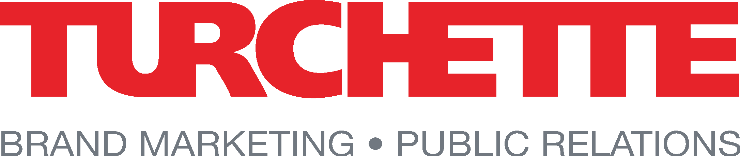

**client:** **Norwalt Automation Group**

**contact:** Christopher Dale

Turchette Agency

(973) 227-8080, ext. 116

[cdale@turchette.com](mailto:cdale@turchette.com)

Keith Harman

Norwalt

(609) 744-1993

[keith@norwalt.com](mailto:keith@norwalt.com)

**Norwalt Automation Group Partners with ei3 to Launch Nexus: A Smarter, Data-Driven Future for Manufacturing Automation**

***Manufacturers can now achieve 24/7 operational intelligence and predictive maintenance without additional IT staff through this AI-powered IIoT integration.***

*Randolph, NJ* – **Norwalt**, a specialist in custom-built automation and line integration machinery for complex manufacturing applications, announces its strategic partnership with **ei3**, a global leader in industrial Internet of Things (IIoT) solutions. Together, the companies have launched **Norwalt Nexus**, a powerful, AI-driven digital platform designed to transform conventional manufacturing equipment into intelligent, proactive systems.

The Nexus platform, now being integrated across Norwalt’s automation systems, addresses the growing talent crisis and increasing demand for smart, data-driven manufacturing. As manufacturers face over **500,000 unfilled positions in the U.S.** and accelerating pressures to implement **Industry 4.0** – particularly in regulated industries where compliance and traceability are critical – Nexus empowers operations to achieve more with fewer resources, unlocking new levels of performance, uptime, and insight.

“With Nexus, we’re taking Norwalt’s precision-built machines and giving them a brain,” said Mike Seitel, Chairman of Norwalt Automation Group. “By combining our mechanical engineering expertise with ei3’s advanced IIoT technology, we’re enabling smarter decisions, predictive maintenance, and continuous improvement, without the need for specialized tech staff.”

**Key Features of Nexus:**

* **Proactive Maintenance** – Predict issues before they occur using AI and real-time wear tracking
* **Custom Alerts & Dashboards** – Stay informed with personalized alerts and performance reports
* **Version Control** – Automatically back up and track all system changes through Nexus
* **Visual Intelligence** – Smart video monitoring tied directly to system events
* **Mobile Accessibility** – Monitor diagnostics and performance remotely via the Nexus app

“Norwalt's integration of our IIoT platform brings the power of data intelligence to the heart of high-performance automation," said Spencer Cramer, CEO of ei3. "Together, we're helping manufacturers achieve actionable visibility with enterprise-grade security while reducing downtime and driving efficiency gains."

By providing an always-on digital operations expert that works around the clock, Nexus addresses critical gaps in talent, training, and system knowledge. It ensures that manufacturing intelligence stays embedded within operations, **not lost with employee turnover**. This partnership reinforces Norwalt’s commitment to delivering future-ready solutions that go beyond automation. With Nexus, customers gain not just a machine, but a continuous optimization engine that evolves with their business.

# # #

**About Norwalt**

For more than five decades, Norwalt has specialized in custom-built automation and line integration machinery for complex manufacturing applications. The company's engineers design, construct, validate and install premium production equipment for a wide array of sectors, including medical devices, life sciences, food & beverage, personal care, and household items. Norwalt produces machinery meeting a broad range of functionalities – from packaging and product assembly and post-mold automation to modular automation cells and robotics systems. Many customers rely on Norwalt’s vision system experience enabling them to incorporate highly technical vision systems, both stand alone and integrated, to ensure accuracy in a wide range of applications.

Often, Norwalt's unique-to-customer solutions comprise intricate, low- to high-volume machinery and robotics designed from proof of concept, many of whose capabilities have never been attempted let alone realized. Always, its equipment provides maximum efficiency and minimal downtime backed by the company’s unsurpassed, engineering-centric customer service and support. For more information visit [www.norwalt.com](http://www.norwalt.com).

**About ei3**  
ei³ has pioneered IIoT applications and AI-driven solutions since 1999, establishing itself as a trusted leader in industrial manufacturing. We unlock the power of every machine, empowering machine builders and manufacturers worldwide to turn manufacturing complexity into competitive advantage through tools that enhance efficiency, promote sustainability, and drive cost savings.

With headquarters in New York and development in Montreal, we serve customers through our comprehensive IIoT platform, powered by triple-redundant data centers in the USA, Germany, and China. Our platform enables over 190,000 industrial assets, maintaining 25 years of zero security incidents. For more information visit: [www.ei3.com](http://www.ei3.com/)