Editorial Contact: Ana Juraga [ana.juraga@ecocortec.hr](mailto:ana.juraga@ecocortec.hr)

Cortec® Europe Advertising Agency + 385 (0) 1 4854 486

Company Contact: Ivana Radic Borsic iborsic@cortecvci.com

Cortec® Corporation: + 385(0) 31 705 011

**Attention: Editor**

**July 23, 2025**

**PRESS RELEASE**



EcoCortec® Unveils Next-Gen Sustainable 3D Bags Powered by VpCI®!

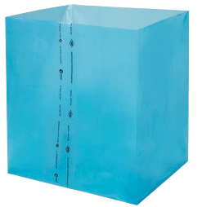EcoCortec®, the European subsidiary of Cortec® Corporation and a leading manufacturer of sustainable VCI/VpCI® packaging, launched a brochure featuring new capabilities of 3D Bags powered by VpCI®, a revolutionary packaging solution designed to provide green corrosion protection for a wide range of metal products. These high-technology bags combine cutting-edge film technology with Cortec’s Vapor phase Corrosion Inhibitors, offering strong protection against rust, tarnish, stains, white rust, and oxidation.

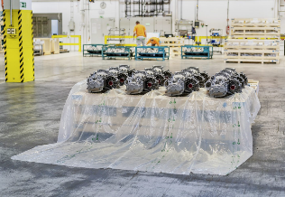The unique three-dimensional shape of these bags allows them to conform effectively to various items, including bulky or irregularly shaped objects, ensuring all-around protection. Clever design of 3D bags powered by VpCI® helps businesses around the world by making their packaging processes smoother and more efficient. A significant highlight of the new 3D Bags Powered by VpCI® is their strong commitment to sustainability. Available in Post-Consumer Recycled (PCR) versions, these bags are developed with a high amount of recycled content, promoting efficient resource recovery, recycling, and reuse. This minimizes the ecological footprint without compromising the superior mechanical and corrosion-inhibiting properties customers expect from EcoCortec®.

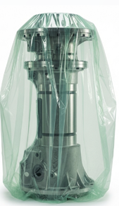**Key Benefits of 3D Bags Powered by VpCI®:**

**Superior corrosion protection**: Bags continuously protect against salt, excessive humidity, condensation, moisture, aggressive industrial atmospheres, and dissimilar metal corrosion.

**Time and cost savings:** 3D Bags Powered by VpCI® replace traditional rust preventatives like oils and desiccants, eliminating the need for degreasing or coating removal. Parts are ready for immediate use upon unpacking, saving significant time and labor.

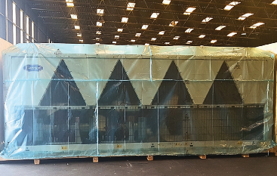**Green sustainable packaging option:** Available in fully recyclable versions, including those with up to 30% post-consumer recycled content. They are transparent for easy part identification, non-toxic, and do not contain free amines, phosphates, or halogen-based materials.

**Versatile & customizable:** Available in various designs, applications, and capabilities, with custom blends for improved puncture resistance, tear strength, or other specific requirements.

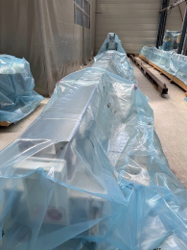

The 3D Bags Powered by VpCI® line includes several advanced versions such as bags preventing both corrosion and electrostatic discharge (ESD) damage, ideal for static-sensitive multi-metal items like electronics as well as VpCI®-126 HP UV Shrink 3D Bags combing VpCI®’s with high-strength resins and UV stabilizers for most aggressive outdoor conditions. Biodegradable and compostable options are also available such as EcoCorr® and EcoWorks® 3D Bags. These biodegradable and industrially compostable corrosion inhibiting film bags, certified by TÜV Austria, disintegrate into carbon dioxide and water within 2-3 months in a commercial composting environment. EcoCortec's 3D VpCI® bags are now available globally to customers, shipped directly from the Beli Manastir plant.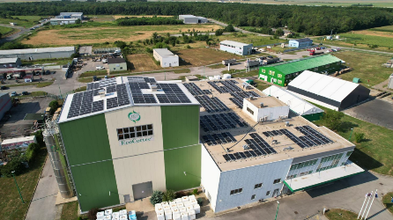 EcoCortec® is dedicated to providing the most environmentally sustainable VpCI®/VCI solutions in the industry, and the new 3D Bags Powered by VpCI® exemplify this commitment, offering a powerful solution for modern industrial packaging needs. As a key European subsidiary of Cortec® Corporation, EcoCortec is a significant center for innovative VCI packaging solutions. EcoCortec's Croatian plant is deeply committed to sustainability integrating it into every aspect of its operations. The facility stands out with its on-site recycling and significant use of recycled content in its manufacturing processes. The plant's operation on solar power demonstrates its commitment to minimizing environmental impact and advancing a circular economy.

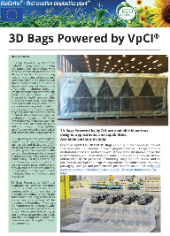

* You can access the brochure featuring the 3D Bags Powered by VpCI® line here:: <https://www.cortecvci.com/whats_new/announcements/3D-Bags.pdf>

***Keywords: corrosion protection, VCI , VpCI, ecocortec, sustainability, 3D bags, VCI packaging, packaging innovations, green solutions, sustainable packaging***

**Need a High-Resolution Photo? Visit:** [**www.cortecadvertising.com**](http://www.cortecadvertising.com)

Cortec® Corporation is the global leader in innovative, environmentally responsible VpCI® and MCI® corrosion control technologies for Packaging, Metalworking, Construction, Electronics, Water Treatment, Oil & Gas, and other industries. Our relentless dedication to sustainability, quality, service, and support is unmatched in the industry. Headquartered in St. Paul, Minnesota, Cortec® manufactures over 400 products distributed worldwide. ISO 9001, ISO 14001:2004, & ISO 17025 Certified.