PRESS RELEASE, june 2025

Hyléance Beauté and 900.care innovate together

On the one hand, 900.care, a startup with a strong commitment. On the other, Hyléance, previously known as Rovip, well-known for its industrial expertise in injection and packaging. They have partnered to develop specific hygiene products: toothbrushes, boxes for toothpaste tablets, shower gel…several years of innovation and co-investment later, 900.care has chosen the puRe Roll-on from Hyléance’s puRe standard range for its new deodorant. The collaboration continues.

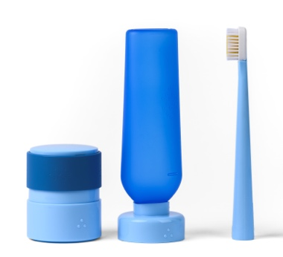
The story of this partnership began just after the COVID years. 900.care decided to launch a range of hygiene and personal care products that were refillable and made in France. The concept is based on the following manifesto: “Let’s stop paying for water and throwing away plastic for the products in our bathrooms,” hence the choice of solid formulas designed to be diluted. A box for toothpaste tablets with a sliding ring, a shower gel bottle with a three-part cap allowing it to be stored upside down, a refillable toothbrush with a lightweight handle manufactured with gas-assisted injection molding…this injected collection combines fun design with intuitive gestures. It requires the development of technical parts and solid experience of packaging and closures.
Since the beginning, Hyléance was on board, backing 900.care’s investments and sharing its challenges, activating its R&D capabilities and co-creating molds and processes. Through this project, Hyléance demonstrated the agility required by the startup model.

Hyléance Beauté’s puRe range in the spotlight
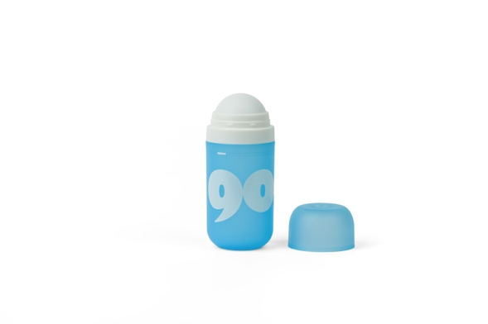
For its new collection developed for major retailers and e-commerce, 900.care chose the puRe Roll-on from Hyléance Beauté’s puRe collection for its low plastic content, impermeability, durability and of course its design. Hyléance adapted the concept with a 50ml model, ideal for holding the tablet and the required dose of water. The PP bottle and cap are injected and dyed in the press and are slightly transparent, allowing control over the level of the formula. It is a highly qualitative product for a mass-market solution that is both accessible and sustainable. Assembly of the different parts is performed at a local ESAT, a facility employing disabled workers, an approach that consolidates the shared values established between the two companies.

“Hyléance has succeeded in transforming our ideas into reality: thanks to this expertise, we are launching a beautiful, refillable 50ml roll-on. The agility and support of Hyléance Beauté at each stage of development have made this collaboration a true success for 900.care,” says Thomas Arnaudo, co-founder of the company.

