Press Release

FOR IMMEDIATE RELEASE

Title: Zeus Packaging Extends Cork City FC Sponsorship, Strengthening Ties Between Global Brand and Local Club

Image:

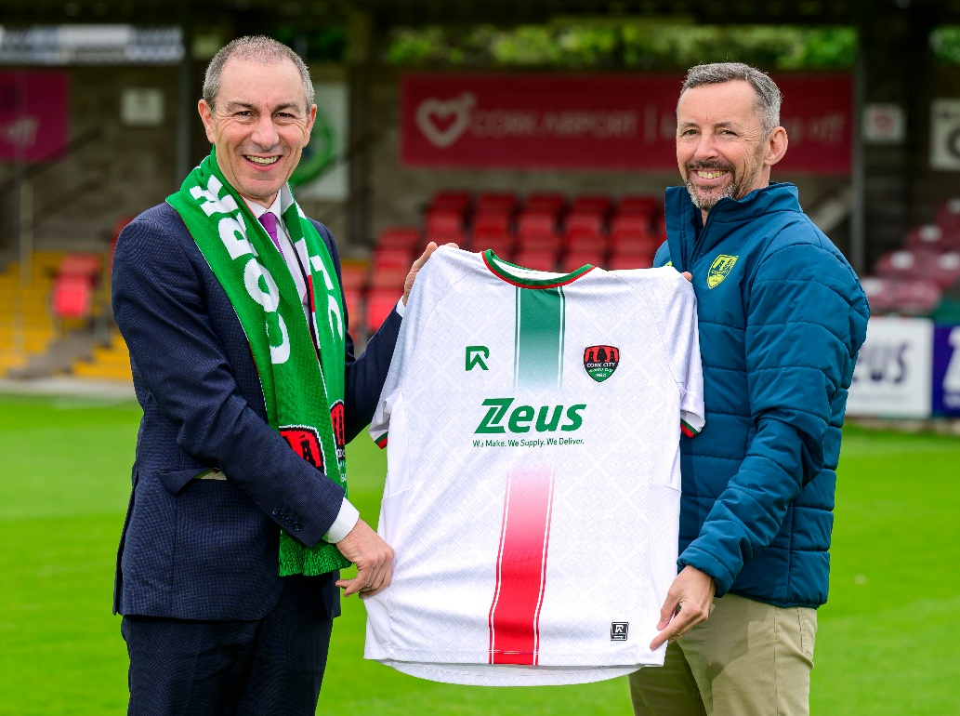

Text:

*Leading Irish-headquartered packaging giant commits to two more years as Premier Club Partner.*

[Cork City FC](https://www.corkcityfc.ie/) has announced the extension of its partnership with [Zeus Packaging](https://global.zeuspackaging.com/), securing the global packaging solutions provider as Premier Club Partner for a further two years. The agreement builds on a successful three-year collaboration that began in 2022 and has seen Zeus Packaging’s branding become a prominent feature on both the Men’s and Women’s first-team jerseys.

Founded in Cork by entrepreneur Brian O’Sullivan in 1998, Zeus Packaging has grown from local roots to become a global leader, employing over 1,300 people across 38 countries and generating annual revenues exceeding €500 million. Despite its international reach, the company maintains strong ties to its Cork origins — ties that are further strengthened through its ongoing commitment to Cork City FC.

Speaking on the renewed partnership, Cork City FC owner Dermot Usher commented:  
*"Zeus Packaging has been an invaluable partner over the last three years, and we’re thrilled to continue this relationship. Having a successful Cork-founded business like Zeus backing the club not only strengthens our community connections but also reflects the ambition and values we share. We are proud to carry the Zeus name on our jerseys as we look ahead to the next two seasons."*

Zeus Packaging founder and CEO Brian O'Sullivan added:  
*“We have seen the positive impact this sponsorship has had on the club, and we are excited about being part of the club’s story for the next two years. We are proud to have the Zeus Packaging logo on the front of the Senior Men’s and Women’s jerseys, especially in front of the home crowd at Turner’s Cross. We look forward to building our relationship further with the club and its fantastic fanbase.”*

The renewed partnership will see Zeus Packaging’s logo remain front and centre on all senior team kits, as the club continues to build on its recent growth and ambitions both domestically and in European competition.

For media inquiries or further information, please contact:

Pip Gorringe

Director of Marketing

Zeus Packaging

[Pip.Gorringe@zeuspackaging.co.uk](mailto:Pip.Gorringe@zeuspackaging.co.uk)

07809737871

**About Zeus Packaging**

Zeus Packaging is a leading provider of sustainable packaging solutions, committed to innovation and excellence in serving a diverse range of industries. With a focus on sustainability and customer satisfaction, Zeus Packaging delivers high-quality, eco-friendly packaging products to clients worldwide. Serving in 38 countries and with 61 locations, Zeus truly is a global packaging solutions provider.

End of Release