New addition to the customer service team at NO-NAIL BOXES: Nadine Fuchs
Wiltz, 18 April 2024
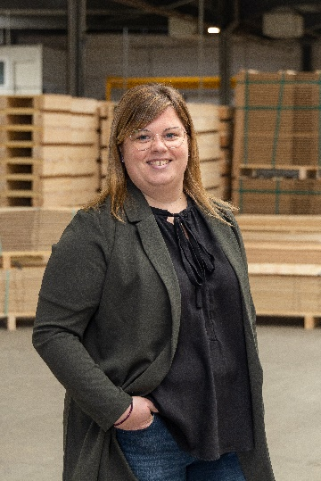
NO-NAIL BOXES, the Luxembourgish manufacturer of folding boxes in plywood and steel, is proud to announce the arrival of Nadine Fuchs to its customer service team.
With a diverse professional background, Nadine has gained valuable experience in various sectors before joining NO-NAIL BOXES. She has developed a strong expertise in handling customer inquiries and administrative management. At NO-NAIL BOXES, Nadine holds the position of customer service employee. Her responsibilities include organizing transports, processing orders, and managing invoicing. Fluent in Luxembourgish, German, French, English, and Dutch, her language skills are a real asset in communicating with clients and suppliers.
Attention to detail, responsiveness, and listening skills are also values that enable Nadine to ensure a positive customer experience. During her free time, Nadine enjoys spending time with her family and friends and pursuing her hobbies (football, traveling, hiking, etc.). Nadine describes herself as ambitious and perfectionistic, always striving to deliver quality work. She is also known for her accessibility and willingness to assist her colleagues at any time.
NO-NAIL BOXES is located in Wiltz and has been manufacturing folding boxes made of plywood and steel for the industry since 1961. Every year, some 450,000 boxes, 95% of which are custom-made, leave its production workshop. Certified ISO 9001, ISO 14001, ISO 27001, AEO, PEFC, CSR, SuperDrecksKëscht fir Betriber and Sécher a Gesond mat System, NO-NAIL BOXES is integrated in the packaging division of the ALIPA Group, a Luxembourg-based specialist in industrial packaging and lifting, which has a total of about 150 employees.
-----------------------------------------
Note for the editors, not for publication
For more information, please contact:

NO-NAIL BOXES (ALIPA Group)
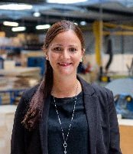
Jenny LENTZ – Project Officer
25, Salzbaach – L-9559 Wiltz
Tel.: +352 81 92 81 259 – Email: jlentz@alipa.lu
Photo: ALIPA Group
Visit our website: www.no-nailboxes.com

