Responsible packaging from NO-NAIL BOXES at LogiMat
Wiltz, 26/01/2023
Are you looking for a responsible packaging solution? Then the folding boxes made of plywood and steel from NO-NAIL BOXES might be for you! From 25 to 27 April 2023, the company will be present at the LogiMat in Stuttgart!
100% recyclable packaging
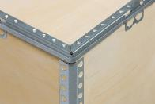
All folding boxes manufactured by NO-NAIL BOXES are made of 100 % plywood and steel. Both materials are particularly easy to recycle once the customers do not want or cannot use them anymore.
In order to ensure that the boxes are properly recycled, NO-NAIL BOXES advises its customers to contact their local waste management facility to collect the boxes for recycling.
The latter will take them to a recycling plant where the boxes will be crushed before the plywood and the steel are automatically separated, the steel particles being easily recovered by magnetization. In this way, the wood will be used, for example, for the production of electricity and heat (cogeneration), while the steel will begin its second life.
Less transport and storage costs
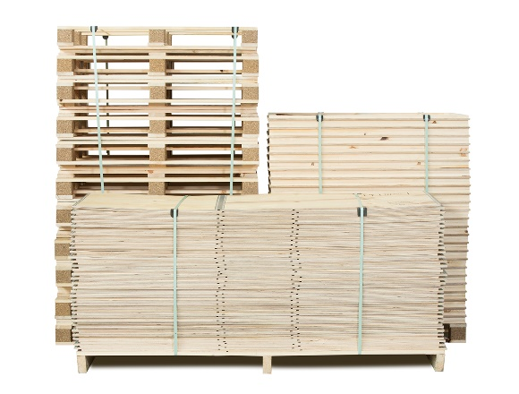
Besides being easily recyclable, the NO-NAIL “BOXES” can be reused several times. This not only saves you money and energy, but also reduces your carbon footprint on the environment. Delivered and stored flat, they optimize empty returns and save up to 85% in storage space.
Michael Franzen, DACH Market Leader, and Joe Reiners, Technical Representative, will welcome you at LogiMat at booth 28, aisle A in hall 2. If you would like more information before your visit, please do not hesitate to contact NO-NAIL BOXES: info@nnb.lu / +352 81 92 81-1.
NO-NAIL BOXES is located in Wiltz and has been manufacturing folding boxes made of plywood and steel for the industry since 1961. Every year, some 450,000 boxes, 95% of which are custom-made, leave its production workshop. Certified ISO 9001, ISO 14001, ISO 27001, AEO, PEFC, CSR, SuperDrecksKëscht fir Betriber and Sécher a Gesond mat System, NO-NAIL BOXES is integrated in the packaging division of the ALIPA Group, a Luxembourg-based specialist in industrial packaging and lifting, which has a total of about 150 employees.

-----------------------------------------
Note for the editors, not for publication
For more information, please contact:

NO-NAIL BOXES (ALIPA Group)
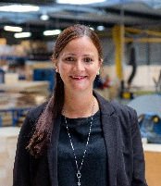
Jenny LENTZ – Project Officer
25, Salzbaach – L-9559 Wiltz
Tel.: +352 81 92 81 259 – Email: jlentz@alipa.lu
Photo: ALIPA Group
Visit our website: www.no-nailboxes.com

